What Can't I Press?
What keyboard shortcuts on your computer are already claimed by different screen readers and apps? Eric W. Bailey has created a free app, What Can't I Press, to help prevent collisions when creating new keybindings.
What Can’t I Press? lives in your macOS menu bar or Windows system tray. Click its icon to open the app. It also displays itself automatically the first time you launch it.
Scan to discover shortcuts
- Detect shortcuts in the app you had open prior to opening What Can’t I Press?, or
- Scan all currently open apps. The full "scan all apps" sweep briefly brings each running app to the foreground to read its menus, then restores focus to where it started.
Search and filter
- Search by intent. Search for keyboard shortcuts or commands to filter the list.
- Search by keypress. Enter keyboard shortcuts to also filter.
Copy to share
- Click a keyboard shortcut row to copy it to your clipboard.
- Hold Control while clicking to copy it as HTML with each key wrapped in a <kbd> element, using the spelled-out key names.
- Hold Shift while clicking to copy the same <kbd> HTML using the displayed symbols.
Export
JSON can be generated for what keyboard shortcuts are currently displayed.
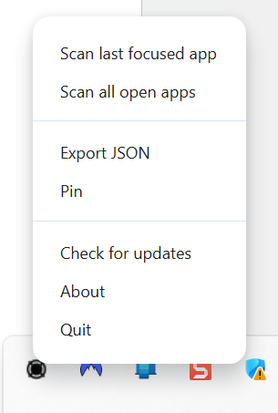
Figure 1: View from Windows system tray
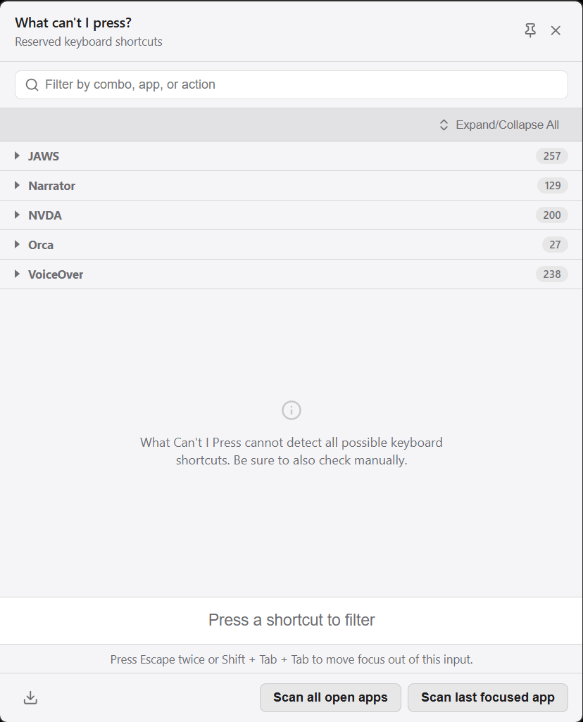
Figure 2: Main menu for What I Can't Press
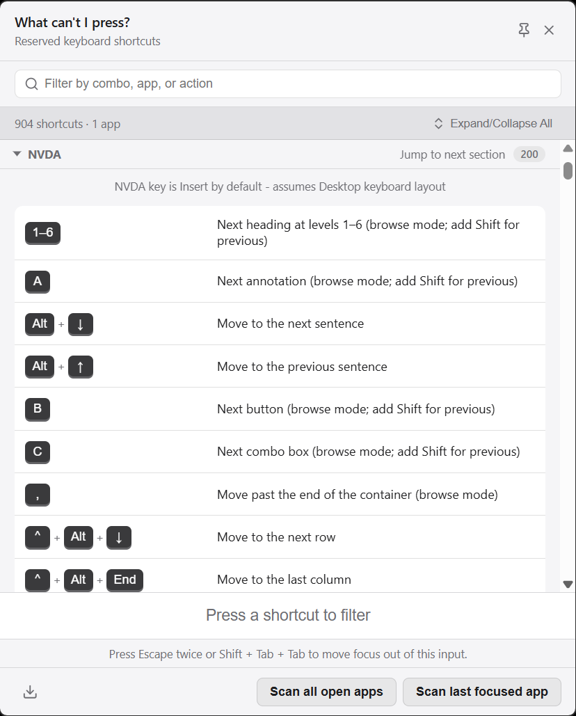
Figure 3: Main menu for What I Can't Press
Example .json file; Windows 11, Gmail opened in Chrome, MS Word opened in Windows 11, NVDA Screen reader running.
Home page: https://github.com/ericwbailey/what-cant-i-press
Requires installer file: WhatCantIPress-1.5.3-universal.dmg or WhatCantIPress-1.5.3-x64.exe

